**Pre-Lab 12:**

**MOSFET Amplifier**

Name: Wan-Yu Liao

ECEN 325 Section 514

TA: Mandela

Date: November 22, 2019

**Calculation**

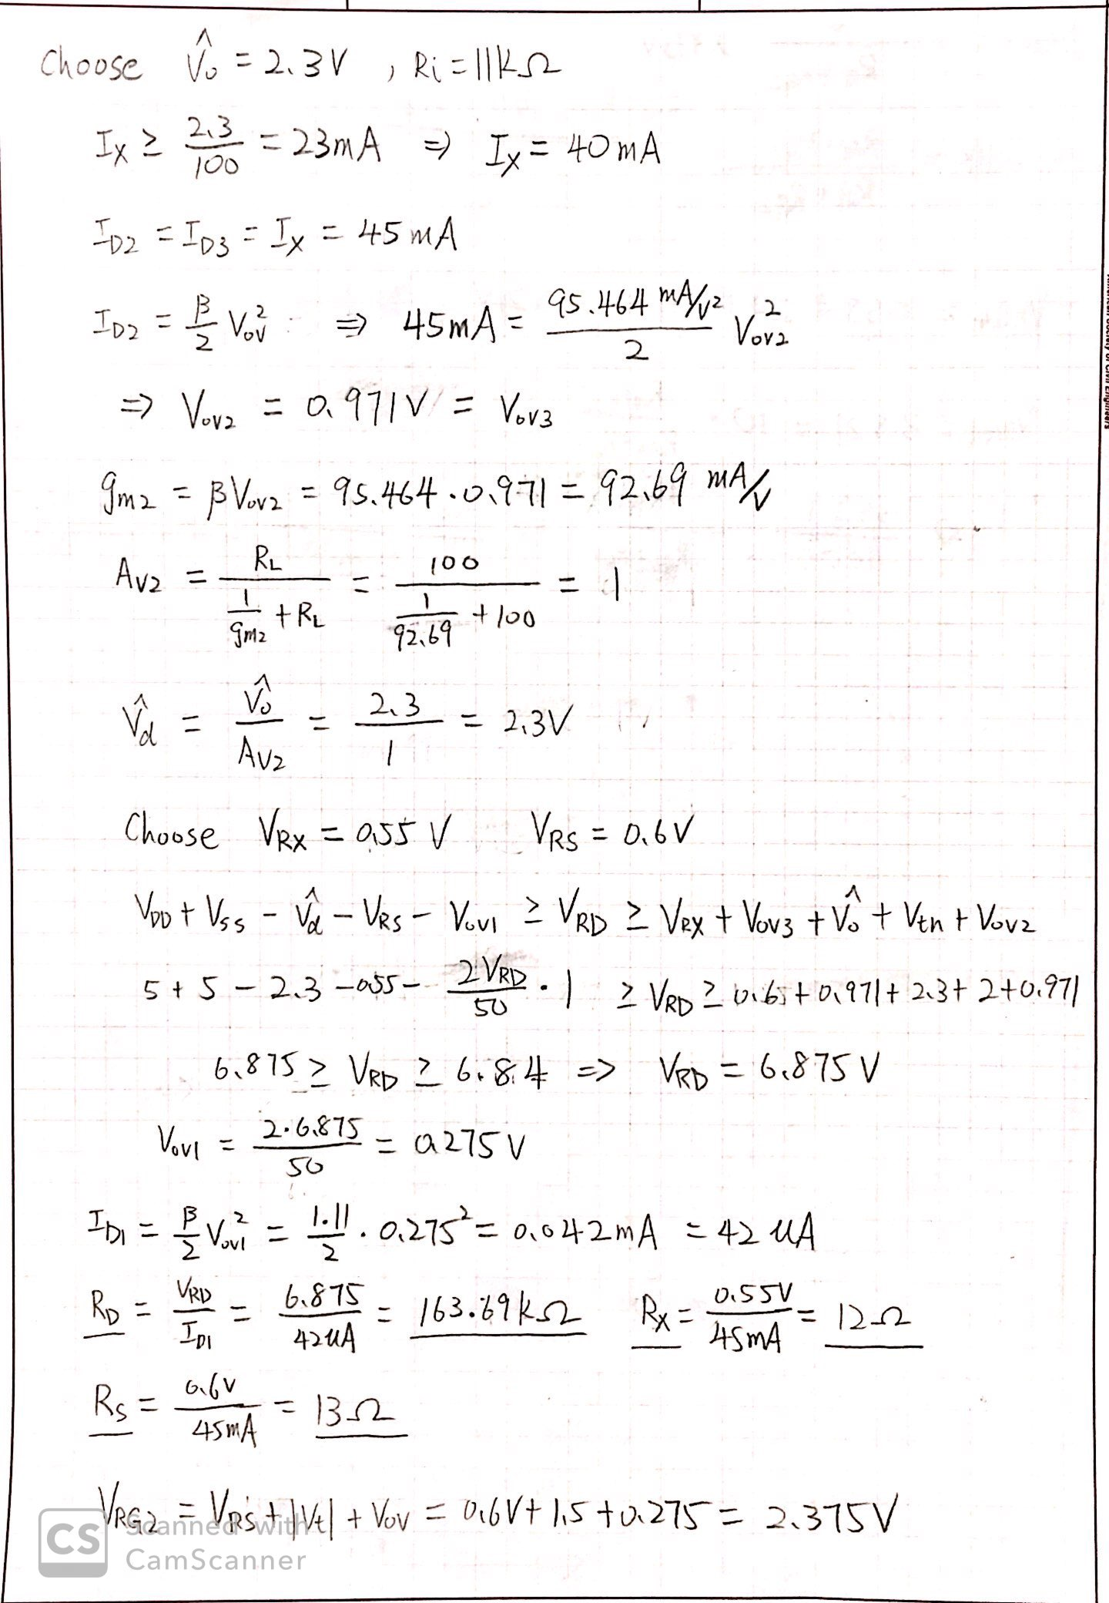

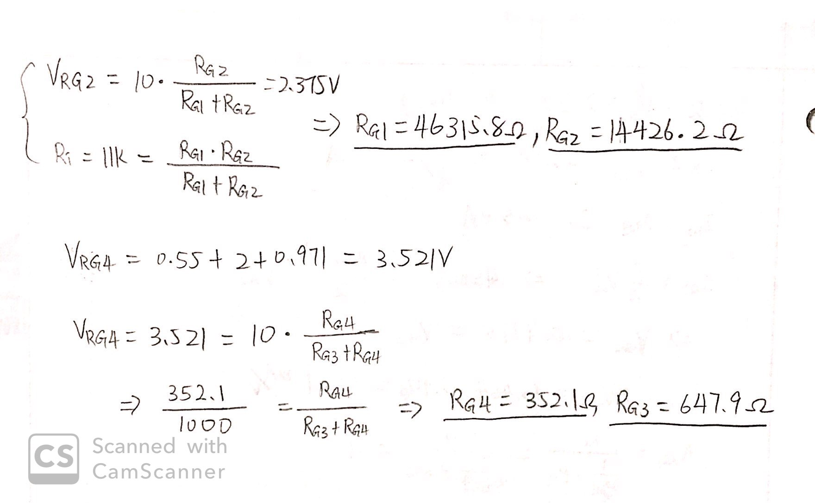

**Simulation**

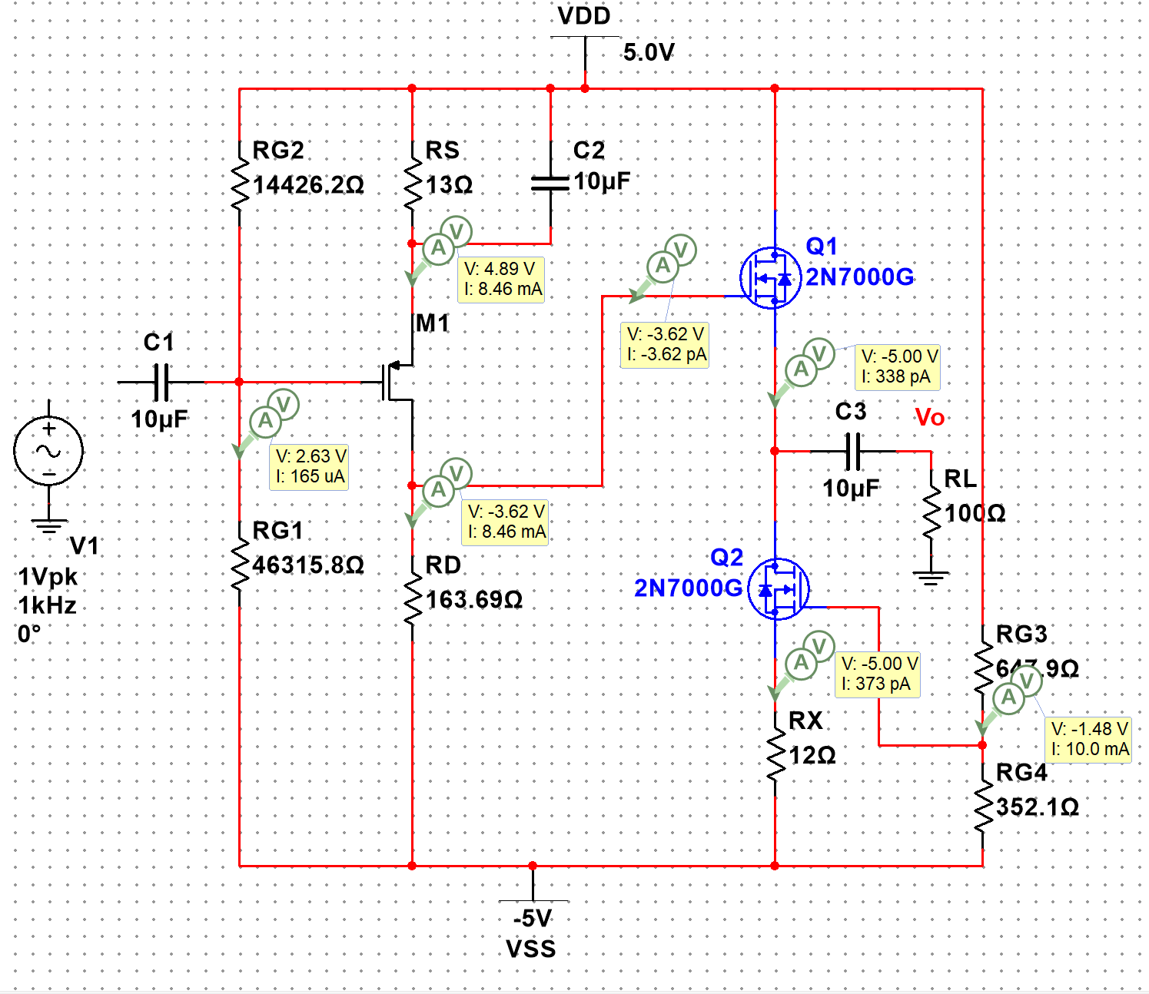

**Figure 1:** DC Solution for MOSFET amplifier ▲

|  |  |  |
| --- | --- | --- |
| VRG1 = 7.63V | VRS = 0.11V | ID1 = 8.46mA |
| VRG2 = 2.37V | VRD = 1.38V | ID2 = 338pA |
| VRG3 = 6.48V |  | ID3 = 373pA |
| VRG4 = 3.52V |  |  |

For this circuit, I got a gain of 0. So I rework the circuit.

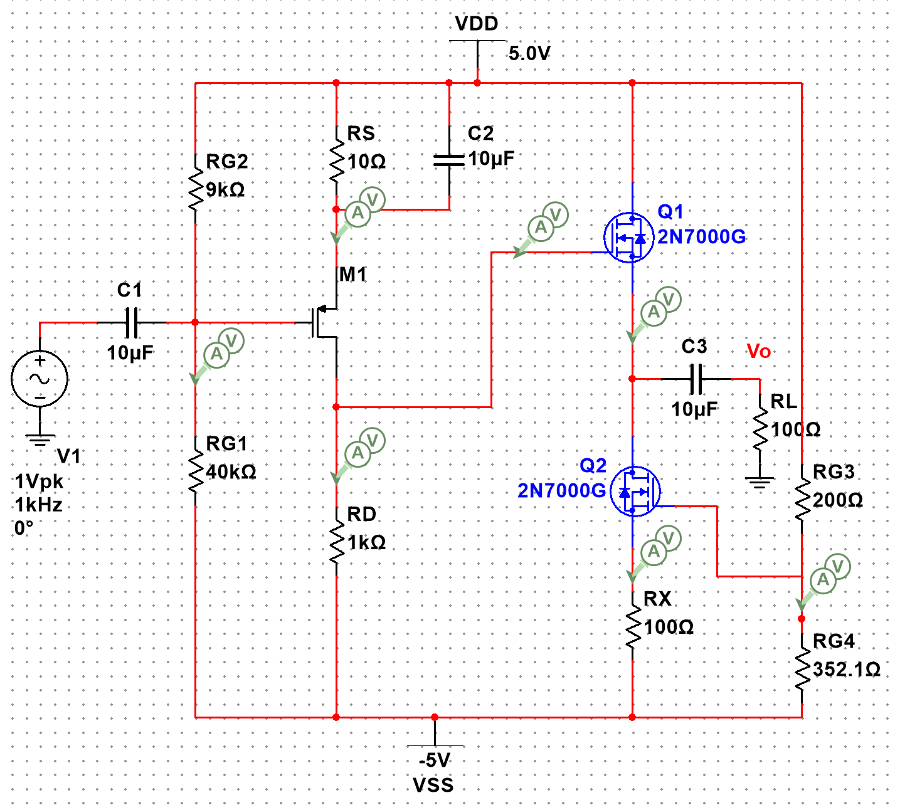

**Figure 1.1:** New circuit for MOSFET amplifier ▲

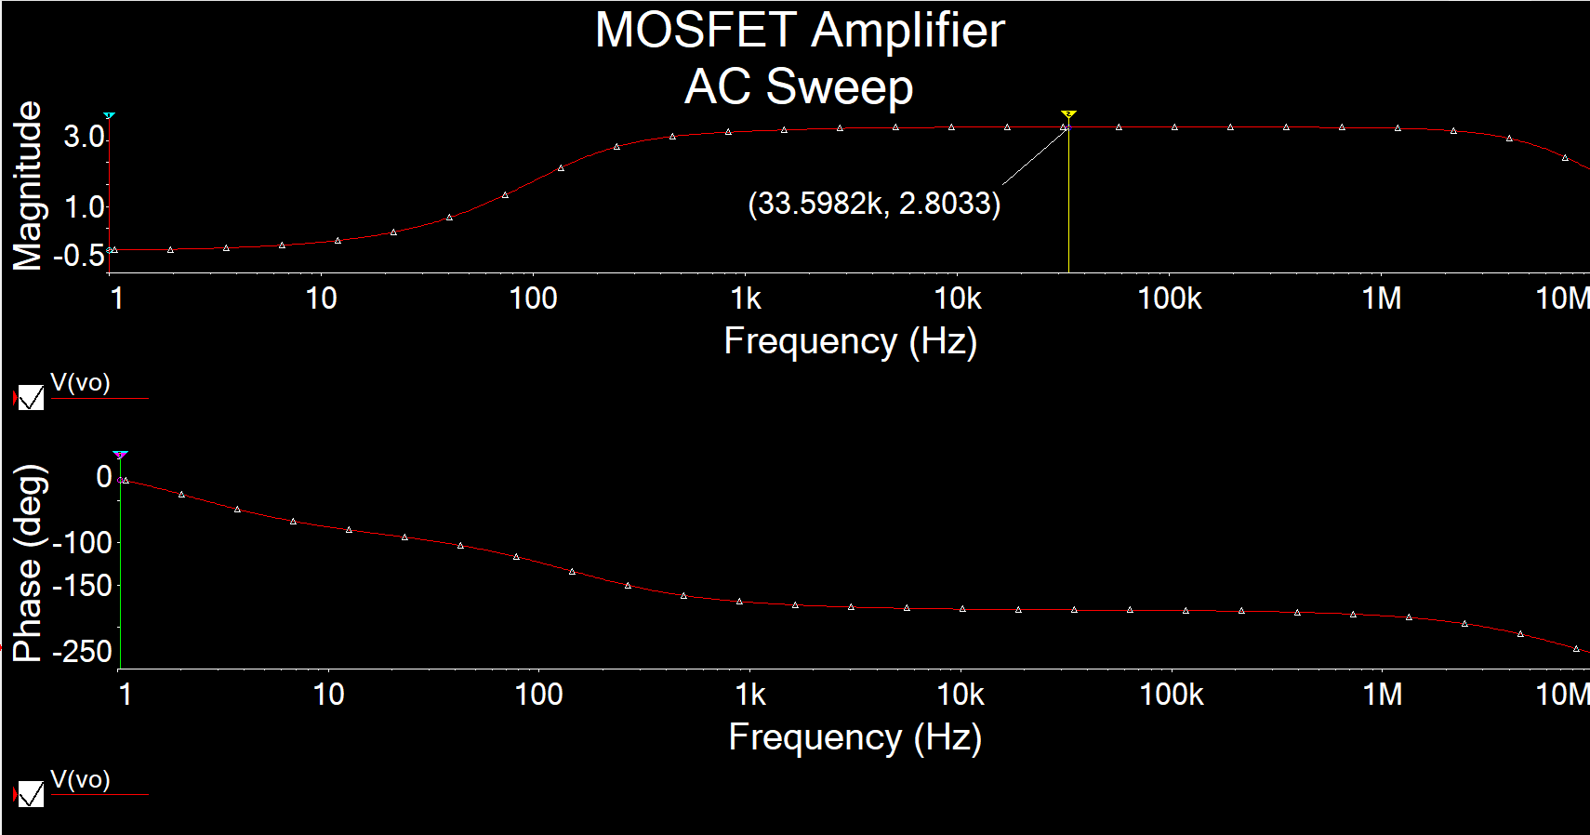

**Figure 2.1:** AC Simulation of AV for MOSFET amplifier ▲

AV = 2.8033

Even I rework the circuit, the best gain I can get is 2.8033.

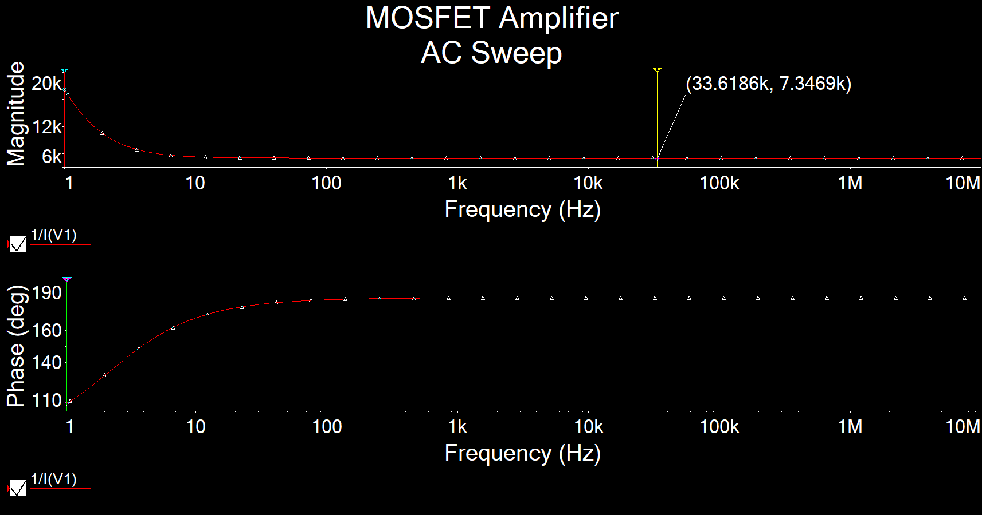

**Figure 2.2:** AC Simulation of Ri for MOSFET amplifier ▲

Ri = 7.3469kΩ

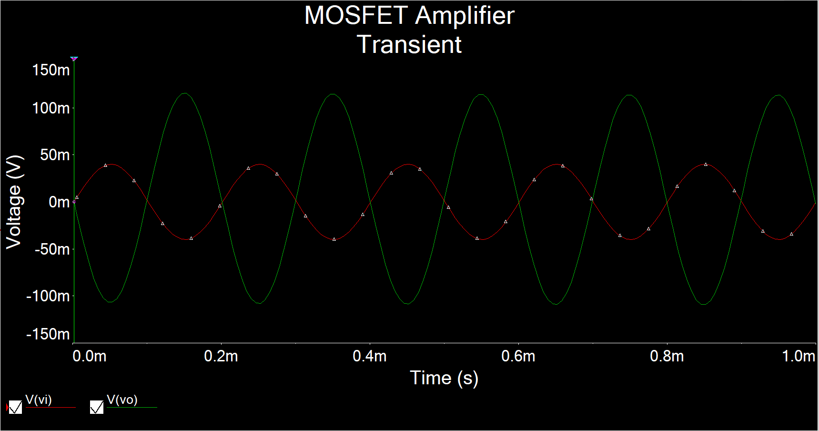

**Figure 3:** Time-domain waveform of Vi = 40mV 5kHzfor MOSFET amplifier ▲

AV

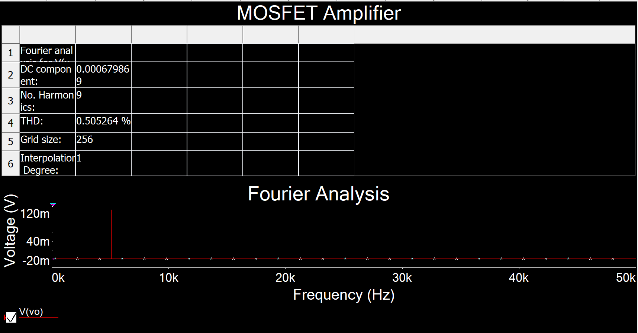

**Figure 4:** Total harmonic distortion (THD) for MOSFET amplifier ▲

THD = 0.5053%